PRESS RELEASE – PARIS – 10 DECEMBER 2021

A new French-Italian Mathematics Laboratory

- Scientific collaboration in mathematical research between France and Italy is highly active in almost all fields.
- After more than twenty years of collaboration, the CNRS and the Istituto Nazionale di Alta Matematica have created the Laboratory Ypatia of Mathematical Sciences (LYSM), a new International Research Laboratory (IRL).
- It is the CNRS’s second IRL in Italy.

The CNRS and the Istituto Nazionale di Alta Matematica, the research organisation that manages, promotes, and coordinates mathematical research in Italy, created the Ypatia Laboratory of Mathematical Sciences (LYSM) on 10 December, 2021. Its objectives are to promote French-Italian exchanges among mathematicians, organise scientific conferences, facilitate the implementation of co-supervised doctoral theses between France and Italy, and fund assignments for doctoral fellows. The LYSM will rely on a consortium that brings together laboratories established in some thirty French and Italian universities.

Scientific collaboration between France and Italy in mathematics is nothing new. It is highly active, and involves almost all fields in mathematics, with a focus on algebraic geometry, complex and differential geometry, dynamic systems, logic, mathematical physics, number theory, and probability theory.

Between 2000 and 2016, the CNRS and the Istituto Nazionale di Alta Matematica (INdAM) directly supported hundreds of French-Italian joint publications through bi-national mathematics programmes. In 2017, the International Associated Laboratory (LIA) LYSM, that gave rise to the new International Research Laboratory (IRL) of the same name, was set up through an agreement between the CNRS and the INdAM.

Today, the creation of the LYSM IRL aims to build a dynamic network of scientific collaboration that will strengthen the links between the two countries in the field of mathematics. It will allow researchers to benefit from long-term stays within the laboratories on which the LYSM IRL is based. Special attention will be given to funding and encouragement for students and young scientists.

The scientific programme for this new IRL will cover all branches of mathematics, including those around which France and Italy are already closely collaborating (see above), but also others that could emerge from the new communities involved in the laboratory’s scientific activities.

The laboratory’s name pays tribute to Hypatia of Alexandria, the Greek philosopher, astronomer, and mathematician (late 4th to early 5th century), who was the first renowned female mathematician.

“I am extremely proud of the creation of this new international laboratory, which perfectly illustrates the CNRS’s international collaboration process: from an International Associated Laboratory with perfectly balanced activities in terms of geography and research themes, to an IRL that will strengthen exchanges between France and Italy. Italy is an important partner for mathematical research, and one of the CNRS’s missions is to maintain and develop relations with its European partners through structured initiatives,” enthuses the CNRS CEO Antoine Petit.

“The scientific collaboration between French and Italian mathematical communities has a long-standing tradition. INdAM is extremely happy about the launch of the International Associated Laboratory LYSM which will provide a powerful and efficient frame that will further increase existing ties between mathematicians from both countries, as well as foster new relations and lay the groundwork for new successes in mathematical research" stresses Giorgio Patrizio, President of the Istituto Nazionale di Alta Matematica (INdAM)

For more information about LYSM : https://www.lysm.eu/fr/

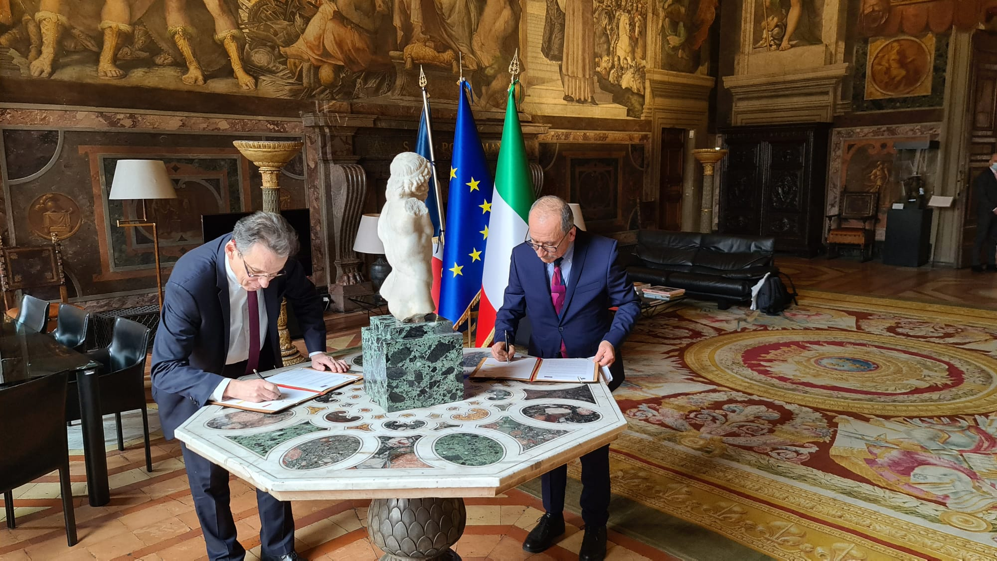
Alain Schuhl the CNRS Chief Research Officer (left) and Giorgio Patrizio, President of the Istituto Nazionale di Alta Matematica (right) © Jean-Stéphane Dhersin, CNRS.

Contact

CNRS press l Alexiane Agullo l T +33 1 44 96 43 90 l alexiane.agullo@cnrs.fr

